DATE: 7/10/2026
EXP1 Estimation of Characteristic Impedance (Zo), and Propagation Constant (γ) of a Transmission Line from Primary Constants
TEST CASE 1:
AIM
Investigating the significance of Characteristic Impedance (Zo), and Propagation Constant (γ) of a Transmission Line with Resistance =10 Ω/Km, Capacitance = 8 µF/Km, Inductance =3.5 mH/Km, Conductance =4 µmho/Km, Frequency= 2 Khz
SOFTWARE REQUIRED:
SCILAB Version 6.1.1
PROCEDURE:
- Open SCILAB software
- Open file-new
- Put the input values
- Type the program
- Execute the program
- End the program

PROGRAM:
clear; clc;
R=10;L=0.003;f=2*10^3;G=4*(10^-6);C=16*(10^-6);
w=2*%pi*f;
Z=R+(%i*w*L);
Y=G+(%i*w*C);
Zo=sqrt(Z/Y);
C=round(real(Zo));
D=round(imag(Zo));
printf('-Zo = %f + j(%f)ohms\n',C,D);
P=sqrt(Z*Y);
a=real(P);
a1=round(a*10000)/10000;
printf('-Attenuation constant a = %f neper/km\n',a1);
b=imag(P);
b1=round(b*10000)/10000;
printf('-Phase constant b = %f radians/km',b1);

OUTPUT TABULATION:

Simulation Results |  |  | Theoretical Results
Z0(ohms) | α(neper/km) | β(radians/km) | α(neper/km) | β(radians/km)
14.000000 + j(-2.000000)ohms | 0.362100 neper/km | 2.776900 radians/km

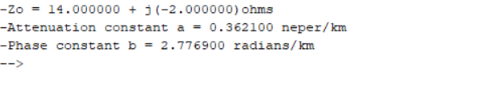
RESULT:
The characteristic impedance and propagation constant of a transmission line is calculated using SCILAB and the impact of primary constants on secondary constants are investigated.

TEST CASE 2:
AIM:
To examine the impact of resistance and inductance on the significance of Characteristic Impedance (Zo) and Propagation Constant (γ) of a Transmission Line at a frequency f=2.5 Khz. Vary the resistance value from 10 Ω to 50 Ω at the interval of 10 Ω with L,G and C values constant and calculate the Characteristic Impedance and Propagation Constant . Vary the inductance values from 3.5 mH to 11.5 mH at the interval of 2.5 mH with R,G and C values constant.

SOFTWARE REQUIRED:
SCILAB Version 6.1.1

PROCEDURE:
- Open SCILAB software
- Open file-new
- Put the input values
- Type the program
- Execute the program
- End the program

PROGRAM:
clear; clc;
R=10;L=0.003;f=2*10^3;G=4*(10^-6);C=16*(10^-6);
w=2*%pi*f;
Z=R+(%i*w*L);
Y=G+(%i*w*C);
Zo=sqrt(Z/Y);
C=round(real(Zo));
D=round(imag(Zo));
printf('-Zo = %f + j(%f)ohms\n',C,D);
P=sqrt(Z*Y);
a=real(P);
a1=round(a*10000)/10000;
printf('-Attenuation constant a = %f neper/km\n',a1);
b=imag(P);
b1=round(b*10000)/10000;
printf('-Phase constant b = %f radians/km',b1);

TABULATION:

S.No. | Inputs (R) | Simulation Z₀ (Ω) | Simulation α (Np/km) | Simulation β (rad/km) | Theoretical α (Np/km) | Theoretical β (rad/km)
1 | 10 | 20 − j3 | 0.2560 | 1.9635 | 0.2560 | 1.9635
2 | 20 | 20 − j5 | 0.5002 | 2.0100 | 0.5002 | 2.0100
3 | 30 | 21 − j7 | 0.7258 | 2.0777 | 0.7258 | 2.0777
4 | 40 | 21 − j9 | 0.9316 | 2.1582 | 0.9316 | 2.1582
5 | 50 | 22 − j11 | 1.1192 | 2.2456 | 1.1192 | 2.2456

OUTPUT:
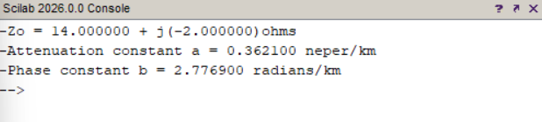

TEST CASE 3:

AIM:
To explore the impact of frequency and capacitance on the significance of Characteristic Impedance (Zo) and Propagation Constant (γ) of a Transmission Line. Vary the frequency from 2KHz to 10 KHz at the interval of 2 KHz with L,R ,G and C values constant and calculate the Characteristic Impedance and Propagation Constant

SOFTWARE REQUIRED:
SCILAB Version 6.1.1

PROCEDURE:
- Open SCILAB software
- Open file-new
- Put the input values
- Type the program
- Execute the program
- End the program

PROGRAM:
clear; clc;
R=10;L=0.003;f=2*10^3;G=4*(10^-6);C=16*(10^-6);
w=2*%pi*f;
Z=R+(%i*w*L);
Y=G+(%i*w*C);
Zo=sqrt(Z/Y);
C=round(real(Zo));
D=round(imag(Zo));
printf('-Zo = %f + j(%f)ohms\n',C,D);
P=sqrt(Z*Y);
a=real(P);
a1=round(a*10000)/10000;
printf('-Attenuation constant a = %f neper/km\n',a1);
b=imag(P);
b1=round(b*10000)/10000;
printf('-Phase constant b = %f radians/km',b1);

TABULATION:
S.No. | Inputs (C) F | Simulation Z₀ (Ω) | Simulation α (Np/km) | Simulation β (rad/km) | Theoretical α (Np/km) | Theoretical β (rad/km)
1 | 8 µF | 34 − j1 | 0.1490 | 4.2175 | 0.1490 | 4.2175
2 | 10 µF | 30 − j1 | 0.1666 | 4.7153 | 0.1666 | 4.7153
3 | 12 µF | 27 − j1 | 0.1825 | 5.1654 | 0.1825 | 5.1654
4 | 14 µF | 25 − j1 | 0.1971 | 5.5793 | 0.1971 | 5.5793
5 | 16 µF | 24 − j1 | 0.2107 | 5.9645 | 0.2107 | 5.9645
OUTPUT:
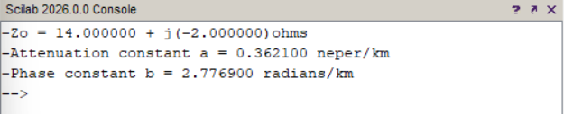

RESULT:
The impact of frequency and capacitance on the significance of Characteristic Impedance (Zo) and Propagation Constant (γ) of a Transmission Line is investigated for various values of frequencies and capacitance values.

